TOMATO & BOCCONCINI CAPRESE SKEWERS

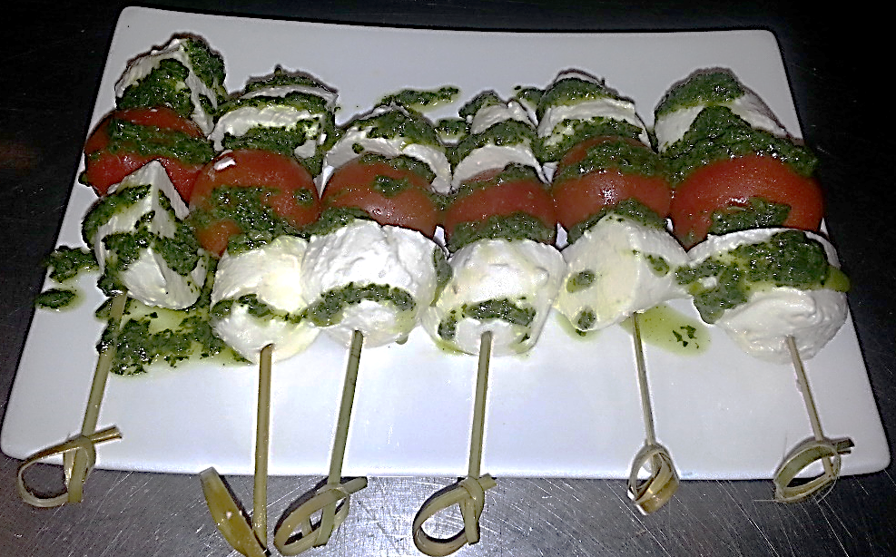

Ingredients:
- 250g tub cherry bocconcini
- 1 punnet cherry tomatoes
- Basil oil (see below)
- Knotted bamboo picks
Method:
- Skewer bocconcini and tomato as per photo, leave tip of skewer covered
- To serve, liberally drizzle with basil oil

BASIL OIL
- 1 bunch basil (remove majority of stalk)
- 125ml vegetable oil
- 30g spinach leaves
- 3g garlic
- 1g salt and pepper
- 15ml lemon juice
- 35ml olive oil
Method
- Blitz together

